Chaperone Policy

Version: | Review date: | Edited by: | Approved by: | Comments:
1 | June 2024 | LJT | AB

Table of contents
1 Introduction 2
1.1 Policy statement 2
1.2 Status 2
1.3 KLOE (England only) 2
1.4 Training and support 3
2 Scope 4
2.1 Who it applies to 4
2.2 Why and how it applies to them 4
3 Definition of terms 4
3.1 Chaperone 4
4 Policy 4
4.1 Raising patient awareness 4
4.2 Personnel authorised to act as chaperones 5
4.3 General guidance 5
4.4 The role of the chaperone 6
4.5 Competencies and training 6
4.6 Disclosure and Barring Service Certificate 7
4.7 Considerations 8
4.8 Confidentiality 8
4.9 When a patient refuses a chaperone 8
4.10 When a chaperone is unavailable 8
4.11 Using chaperones during a video consultation 9
4.12 Practice procedure (including SNOMED codes) 9
4.13 Escorting of visitors and guests (including VIPs) 10
4.14 Summary 11

Annex A – Chaperone poster 12

Introduction

Policy statement

The purpose of this document is to ensure conformity to achieve a common standard of medical practice. This is achieved by enabling the patient to have a chaperone present during the consultation and clinical examination of the patient.

Medical examinations can, at times, be perceived as intrusive by the patient so having a chaperone present protects both the patient and staff member.

Throughout this policy, extracts have been taken from CQC Mythbuster 15: Chaperones.

Status

This document and any procedures contained within it are non-contractual and may be modified or withdrawn at any time. For the avoidance of doubt, it does not form part of your contract of employment.

The organisation aims to design and implement policies and procedures that meet the diverse needs of our service and workforce, ensuring that none are placed at a disadvantage over others, in accordance with the Equality Act 2010. Consideration has been given to the impact this policy might have with regard to the individual protected characteristics of those to whom it applies.

KLOE (England only)

The Care Quality Commission (CQC) would expect any primary care organisation to have a policy to support this process and this should be used as evidence of compliance against the CQC Key Lines of Enquiry (KLOE).

Specifically, Addingham Surgery will need to answer the CQC Key Questions on “Safe”, “Effective”, “Caring” and “Responsive”.

The following is the CQC definition of Safe:

By safe, we mean people are protected from abuse* and avoidable harm. *Abuse can be physical, sexual, mental or psychological, financial, neglect, institutional or discriminatory abuse.

CQC KLOE S1 | How do systems, processes and practices keep people safe and safeguarded from abuse?

The following is the CQC definition of Effective:

By effective, we mean that people’s care, treatment and support achieve good outcomes, promote a good quality of life and are based on the best available evidence.

CQC KLOE E1 | Are people’s needs assessed and care and treatment delivered in line with current legislation, standards and evidence-based guidance to achieve effective outcomes?
CQC KLOE E6 | Is consent to care and treatment always sought in line with legislation and guidance?

The following is the CQC definition of Caring:

By caring, we mean that the service involves and treats people with compassion, kindness, dignity and respect.

CQC KLOE C1 | How does the service ensure that people are treated with kindness, respect and compassion and that they are given emotional support when needed?
CQC KLOE C2 | How does the service support people to express their views and be actively involved in making decisions about their care, treatment and support as far as possible?
CQC KLOE C3 | How are people’s privacy and dignity respected and promoted?

The following is the CQC definition of responsive:

By responsive, we mean that services meet people’s needs.

CQC KLOE R1 | How do people receive personalised care that is responsive to their needs?

Training and support

Addingham Surgery will provide guidance and support to help those to whom it applies to understand their rights and responsibilities under this policy. Additional support will be provided to managers and supervisors to enable them to deal more effectively with matters arising from this policy.

Chaperone awareness training is available on the HUB.

Scope

Who it applies to

This document applies to all employees of the organisation and other individuals performing functions in relation to the organisation, such as agency workers, locums and contractors.

Furthermore, it applies to clinicians who may or may not be employed by the organisation but who are working under the Additional Roles Reimbursement Scheme (ARRS).

Why and how it applies to them

It is a requirement that, where necessary, chaperones are provided to protect and safeguard both patients and clinicians during intimate examinations and or procedures.

All clinical staff may at some point be asked to act as a chaperone at Addingham Surgery. Therefore, it is essential that clinical personnel are fully trained and aware of their individual responsibilities when performing chaperone duties.

Definition of terms

Chaperone

A chaperone can be defined as ‘an independent person, appropriately trained, whose role is to observe independently the examination/procedure undertaken by the doctor/health professional to assist the appropriate doctor-patient relationship’.

The term implies that the person may be a healthcare professional. However, it can also mean a specifically trained non-clinical staff member.

Policy

Raising patient awareness

At Addingham Surgery, a chaperone poster is clearly displayed in the waiting area, in all clinical areas and annotated in the practice leaflet as well as on the practice website.

All patients should routinely be offered a chaperone, ideally at the time of booking the appointment and the importance of a chaperone should not be underestimated or understated. For children and young people, their parents, relatives and carers should be made aware of the policy and why this is important.

A chaperone poster is available at Annex A

Personnel authorised to act as chaperones

It is policy that any member of the practice team can act as a chaperone provided that they have undertaken appropriate chaperone training.

Patients must be advised that a family member or friend is not permitted to act as a chaperone as they are not deemed to be impartial even if they have the requisite training or clinical knowledge. However, they may be present during the procedure/examination if the patient is content with this decision.

General guidance

It may be appropriate to offer a chaperone for a number of reasons. All clinicians should consider using a chaperone for some or all of the consultation and not solely for the purpose of intimate examinations or procedures. This applies whether the clinician is of the same gender as the patient or not.

Before conducting any intimate examination, the clinician must obtain the patient’s consent and:

- Explain to the patient why an examination is necessary and give the patient an opportunity to ask questions

- Explain what the examination will involve, in a way the patient can understand, so that the patient has a clear idea of what to expect, including any pain or discomfort

- Get the patient’s consent before the examination and record that the patient has given it

- Offer the patient a chaperone

- Give the patient privacy to undress and dress and keep them covered as much as possible to maintain their dignity. Do not help the patient to remove clothing unless they have asked you to do so or you have checked with them that they want you to help

- If the patient is a young person or child, you must:

  - Assess their capacity to consent to the examination
  - Seek parental consent if they lack capacity,

Ensuring that the patient fully understands the why, what and how of the examination process should mitigate the potential for confusion.

The role of the chaperone

The role of the chaperone varies on a case-by-case basis taking into consideration the needs of the patient and the examination or procedure being carried out. A chaperone is present as a safeguard for all parties and is an impartial witness to continuing consent of the examination or procedure.

All medical consultations, examinations and investigations are potentially distressing. Patients can find examinations, investigations or photography involving the breasts, genitalia or rectum particularly intrusive and this is important when examinations are performed by members of the opposite sex. These examinations are called 'intimate examinations'.

A chaperone may be required for any consultation where a patient may feel vulnerable.

Cultural factors should also be considered.

For most patients and procedures, respect, explanation, consent and privacy are all that is needed. These take precedence over the need for a chaperone. A chaperone does not remove the need for adequate explanation and courtesy. Neither can a chaperone provide full assurance that the procedure or examination is conducted appropriately.

The Royal College of Nursing have produced a publication on genital examination in women. It includes some useful information on chaperoning which is applicable regardless of gender.

Competencies and training

Staff who undertake a formal chaperone role must have been trained so they develop the competencies required. Training can be delivered externally or provided in-house by an experienced member of staff so that all formal chaperones understand the competencies required for the role.

Expectations of chaperones are listed in the GMC guidance. It states chaperones should:

- Be sensitive and respect the patient’s dignity and confidentiality
- Reassure the patient if they show signs of distress or discomfort
- Be familiar with the procedures involved in a routine intimate examination
- Stay for the whole examination and be able to see what the doctor is doing, if practical
- Be prepared to raise concerns if they are concerned about the doctor’s behaviour or actions

In addition, the chaperone may be expected to:

- Act as an interpreter
- Provide emotional comfort and reassurance to patients
- Assist in the examination (handing equipment to clinicians)
- Assist with undressing or dressing the patient but only should a patient require assistance
- Provide protection for the clinician (against unfounded allegations or attack)
- Witness the procedure (ensuring that it is appropriately conducted)

Training should include:

- What is meant by the term ‘chaperone’
- What an 'intimate examination' is
- A knowledge of the range of examinations or procedures they may be expected to witness
- Why they need to be present, including positioning inside the screened-off area
- Their role and responsibilities as a chaperone. Note that it is important that chaperones place themselves inside the screened-off area rather than outside the curtains/screen (if outside, they are then not technically chaperoning)
- How to raise concerns in conjunction with practice policy
- The rights of the patient
- The requirement to annotate their presence on the individual’s healthcare record post consultation

Training will be undertaken by all staff who may be required to act as a chaperone at Addingham Surgery and can be accessed through Bluestream Training or by an external provider.

Disclosure and Barring Service Certificate

To act as a chaperone, staff who undertake this role should have a Disclosure and Barring Service (DBS) Certificate. This is further supported and is detailed in GP Mythbuster 2.

Whilst clinical staff who undertake this role will already have a DBS check, the CQC has recently determined that non-clinical staff may also need a DBS check in order to act as a chaperone due to the nature of chaperoning duties and the level of patient contact.

It should be noted that if Addingham Surgery decide that a DBS check will not be conducted for any non-clinical staff, then the organisation needs to provide a clear rationale for the decision. This should be supported by an appropriate risk assessment and as further detailed within the DBS Policy.
It is also the case that once a member of staff has a DBS check in place, there is no requirement to repeat it as long as there are no changes to their employment and it is up to this organisation to decide if and when a new check is needed.

For any staff that has not received a repeat DBS check, this organisation will provide evidence that they have appropriately considered this and that it is supported by a risk assessment that details any mitigating actions.

Considerations

In a diverse multicultural society, it is important to acknowledge the spiritual, social and cultural factors associated with the patient population. Clinicians must respect the patient’s wishes and, where appropriate, refer them to another practitioner to have the examination or procedure undertaken.

Local guidance should be sought regarding patients suffering from mental illness or those with learning difficulties. A relative or carer will prove to be a valuable adjunct to a chaperone.

It is also important that children and young people are provided with chaperones. The GMC guidance states that a relative or friend of the patient is not an impartial observer. They would not usually be a suitable chaperone.

There may be circumstances when a young person does not wish to have a chaperone and any reason for this should be clear and recorded.

Confidentiality

Chaperones are to ensure that they adhere to the Caldicott and information governance policies. The clinician carrying out the examination or procedure should reassure the patient that all clinical staff within the practice fully understand their obligation to always maintain confidentiality.

Further reading can be sought from both the Caldicott and Confidentiality Policy and also the Confidentiality and Data Protection Handbook.

When a patient refuses a chaperone

When a patient is offered but does not want a chaperone, it is important the practice has records and codes in the record:

- Who the chaperone was
- Their title
- That the offer was made and declined

When a chaperone is unavailable

If the patient has requested a chaperone and none is available, the patient must be able to reschedule within a reasonable timeframe. If the seriousness of the condition means a delay is inappropriate, this should be explained to the patient and recorded in their notes. A decision to continue or not should be reached jointly.

Special consideration needs to be given to examinations performed during home visits or online, video or telephone consultations.

Using chaperones during a video consultation
See extract from CQC GP Mythbuster 15.
Many intimate examinations will not be suitable for a video consultation. Where online, video or telephone consultations take place, GMC guidance explains how to protect patients when images are needed to support clinical decision making. This includes appropriate use of photographs and video consultations as part of patient care.
Where intimate examinations are performed, it is important that a chaperone is offered. Documentation should clearly reflect this. It is important to document who provided the chaperoning. It should also state what part of the consultation they were present for. For further advice on audio and video consultations, plus the management of any imagery, refer to the Audio visual and photography policy.
NHS England has produced some key principles for intimate clinical assessments undertaken remotely in response to COVID-19. They include how to conduct intimate examinations by video and the use of chaperones.

Practice procedure (including SNOMED codes)

If a chaperone was not requested at the time of booking the appointment, the clinician will offer the patient a chaperone explaining the requirements:

- Contact reception and request a chaperone

- Record in the individual’s healthcare record that a chaperone is present and identify them

- The chaperone should be introduced to the patient

- The chaperone should assist as required but maintain a position so that they are able to witness the procedure/examination (usually at the head end)

- The chaperone should adhere to their role at all times

- Post procedure or examination, the chaperone should ensure they annotate in the patient’s healthcare record that they were present during the examination and there were no issues observed

- The clinician will annotate in the individual’s healthcare record the full details of the procedure as per current medical records policy

Detail | SNOMED CT Code
The patient agrees to a chaperone | 1104081000000107
Refusal to have a chaperone present | 763380007
No chaperones available | 428929009

Escorting of visitors and guests (including VIPs)

There may be, on occasion, a need to ensure that appropriate measures are in place to escort visitors and guests including Very Important People (VIPs). Addingham Surgery will follow the recommendations outlined in the Lampard Report (2015):

- Ensure that any visitors are escorted by a permanent member of staff at all times throughout the duration of their visit

- The individual organising the visit must arrange for a suitable member of staff to act as an escort. Furthermore, the reason for the visit must be documented, giving details of the areas to be visited and if patients are to be contacted during the visit

- The escort is to ensure that no visitors enter clinical areas where there may be intimate examinations or procedures taking place. This protects and promotes the privacy, dignity and respect of patients

- The person arranging the visit must ensure that there is sufficient time for the practice team to advise patients of the visit and offer patients the opportunity to decline to interact with the visitor(s)

- Given the diverse nature of the patient population, some patients may not understand or may become confused as to why visitors or guests (including VIPs) are present. To minimise any confusion or distress, such patients as well as the visitor(s) are to be offered an escort

- The person arranging the visit must ensure that the visitor(s) has produced photographic ID prior to the visit taking place

- The escort is to accept responsibility for the visitor(s) at all times. They must also be prepared to challenge any unacceptable or inappropriate behaviour, reporting such incidences to the practice manager immediately

- The escort must ensure that no patient records or other patient-identifiable information are disclosed to the visitor(s). Escorts are to ensure that the visitor(s) is aware of the need to retain confidentiality should they overhear clinical information being discussed. Any breaches of confidentiality are to be reported immediately to the practice manager

- If media interest is likely, the practice manager is to inform Communications at the ICS, requesting that the communication team provides guidance

- Under no circumstances is the escort to leave the visitor(s) alone with any patient or patient-identifiable information. This is to ensure that both the patient and visitor(s) are appropriately protected

Summary

The relationship between the clinician and patient is based on trust and chaperones are a safeguard for both parties at Addingham Surgery.

The role of a chaperone is vital in maintaining a good standard of practice during consultations and examinations. Regular training for staff and raising patient awareness will ensure that this policy is maintained.

Annex A – Chaperone poster

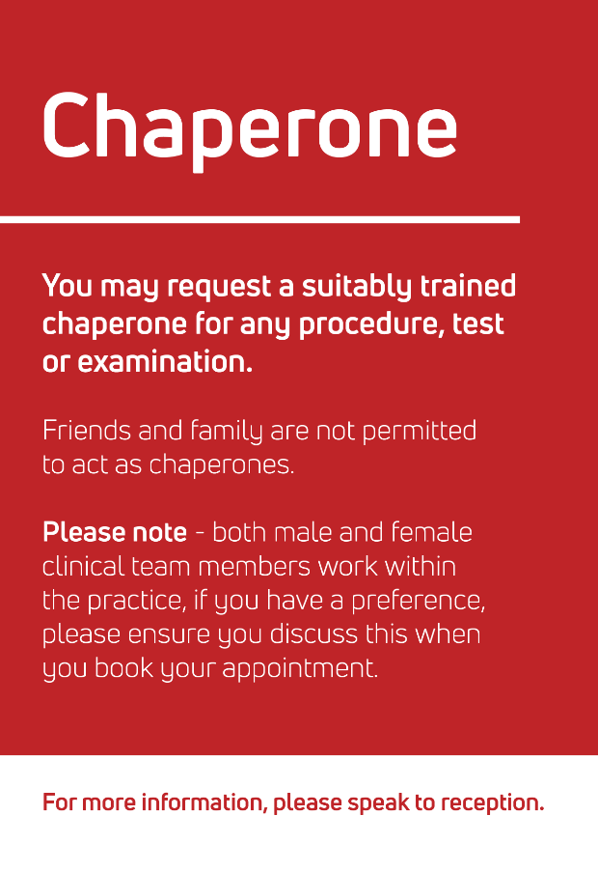

This poster is available here.

KLOE
Network DES Contract specification 2022/23
GMC Ethical Guidance Intimate examination and chaperones
NHS England Consent to treatment
CQC GP Mythbuster 15
SNOMED CT Browser
Lampard Report (2015)

